**Studify Enrollment Dashboards Documentation**

### **1. Users Details Dashboard**

**Dashboard Overview:** The Users Details dashboard presents a comprehensive overview of the user base on the Studify platform. It highlights the total number of users, active students, and instructors, and provides insights into user activity and registration trends.

**Key Metrics:**

* **Total Users:** 5,176 users.
* **Active Students:** 4,219 students.
* **Active Instructors:** 957 instructors.
* **Monthly New Users Trend:** Line chart showing fluctuations in new registrations per month.
* **User Role Distribution:** Pie chart illustrating the proportion of students to instructors.

**Insights:**

* The majority of platform users are students (around 82%).
* There is consistent growth in user registrations with slight seasonal variations.

**Recommendations:**

* Focus marketing campaigns towards students to maintain platform growth.
* Offer incentives for instructors to join to balance user roles.

### **2. Courses Overview Dashboard**

**Dashboard Overview:** The Courses Overview dashboard offers a summary of all available courses on the platform, highlighting popular categories, paid versus free courses, and overall engagement.

**Key Metrics:**

* **Total Courses:** 453 courses.
* **Paid vs Free Courses:** 42% Paid, 58% Free.
* **Top Categories by Number of Courses:**
  + Health & Fitness
  + Development
  + Business
* **Top Instructors by Number of Courses:** Listed with a bar chart.
* **Course Distribution by Category:** Illustrated using a stacked column chart.

**Insights:**

* Free courses dominate, providing a gateway for user acquisition.
* Some instructors have contributed significantly more courses than others.

**Recommendations:**

* Encourage top instructors to develop paid courses to increase revenue.
* Identify popular categories and promote them further through featured sections.

### **3. Courses Details Dashboard**

**Dashboard Overview:** The Courses Details dashboard delves deeper into individual course performances, analyzing course ratings, prices, enrollments, and satisfaction indexes.

**Key Metrics:**

* **Top Rated Courses:** Courses with average ratings close to 5.
* **Top Enrolled Courses:** Courses with the highest student enrollments.
* **Revenue by Course:** Analysis of revenue generated per course.
* **Course Satisfaction Index:** Overall satisfaction percentages by course.
* **Paid vs Free Analysis:** Impact of pricing on enrollments and satisfaction.

**Insights:**

* Courses with a balanced price and high-quality content outperform free courses in revenue.
* High enrollment is directly linked to courses with better ratings and satisfaction.

**Recommendations:**

* Regularly update and improve course content to maintain high ratings.
* Analyze low-performing courses and identify areas for improvement.

### **4. Enrollment Details Dashboard**

**Dashboard Overview:** The Enrollment Details dashboard tracks student enrollments, trends over time, and retention rates across different courses and categories.

**Key Metrics:**

* **Total Enrollments:** 25,382 enrollments.
* **Monthly Enrollments Trend:** Visualized via a line graph.
* **Top Enrolled Categories:**
  + Development
  + Business
  + Health & Fitness
* **Top Courses by Enrollments:** Listed with bar charts.
* **Enrollment Status:** Paid vs Free enrollments.

**Insights:**

* Enrollments are higher for free courses but retention is stronger among paid courses.
* Development and Business courses are the most popular.

**Recommendations:**

* Implement upselling strategies for free courses.
* Increase marketing focus on categories with high enrollment but lower retention.

### **5. Reviews Details Dashboard**

**Dashboard Overview:** The Reviews Details dashboard provides a summary of student feedback and course ratings, assessing overall satisfaction and the impact of course completion rates.

**Key Metrics:**

* **Total Reviews:** 14,000 reviews.
* **Positive Reviews:** 6,964 reviews.
* **Completion Rate:** 68%.
* **Satisfaction Index:** 68%.
* **Positive Review Rate:** 50%.
* **Reviews per Course:** 45%.
* **Satisfaction Index & Completion Rate by Category:** Displayed in a combined bar and line chart.
* **Rating and Duration Correlation:** Scatter plot showing rating vs course length.
* **Top Courses by Satisfaction Index:** Visualized via bubble chart.
* **Satisfaction Index Paid vs Free:**
  + Paid Courses: 78% Satisfaction.
  + Free Courses: 53% Satisfaction.

**Insights:**

* Paid courses consistently achieve higher satisfaction levels.
* Positive reviews are concentrated among courses with moderate to high completion rates.
* A balance between course duration and engagement is essential for better ratings.

**Recommendations:**

* Encourage reviews post-course completion to increase review rates.
* Focus on improving free courses' quality to boost satisfaction.
* Optimize course durations to match learner expectations for better reviews.

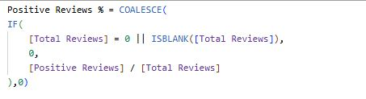

### Measure Name: **Positive Reviews %**

* **Description:**  
  Represents the percentage of positive reviews out of the total number of reviews.
* **Purpose:**  
  To evaluate the overall satisfaction of users by analyzing the proportion of positive feedback.
* **Handling Null or Zero Values:**  
  If the total number of reviews is zero or blank, the result defaults to 0 to avoid division errors.

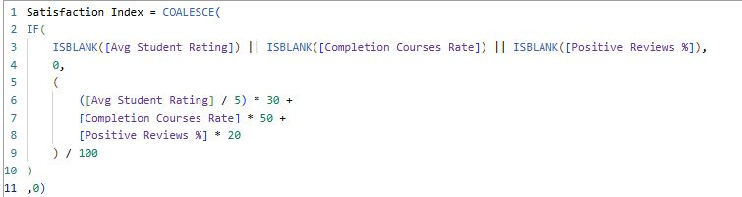

### Measure Name: **Satisfaction Index**

* **Description:**  
  A composite score that reflects overall student satisfaction based on multiple engagement and feedback metrics.
* **Purpose:**  
  To provide a single, weighted indicator of student satisfaction by combining average student ratings, course completion rates, and positive review percentages.
* **Handling Null or Zero Values:**  
  If any of the contributing measures are blank, the result defaults to 0 to maintain data integrity.

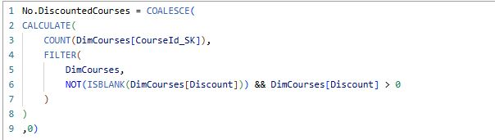

### Measure Name: **No. Discounted Courses**

* **Description:**  
  Counts the number of courses that have an active discount greater than zero.
* **Purpose:**  
  To track how many courses are currently offered with a discount, helping to monitor promotional activities and pricing strategies.
* **Handling Null or Zero Values:**  
  If no discounted courses are found, the measure safely defaults to 0.



### Measure Name: **Monthly Enrollments**

* **Description:**  
  Calculates the total number of course enrollments over the past month.
* **Purpose:**  
  To monitor and analyze enrollment trends on a monthly basis, helping to identify growth patterns or seasonal changes.
* **Handling Null or Zero Values:**  
  If no enrollments are recorded during the period, the measure defaults to 0.

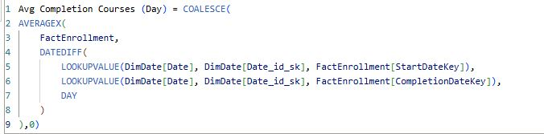

### Measure Name: **Avg Completion Courses (Day)**

* **Description:**  
  Calculates the average number of days students take to complete their enrolled courses.
* **Purpose:**  
  To measure learner engagement and course pacing by identifying the average course completion time.
* **Handling Null or Zero Values:**  
  If no valid completion data is available, the measure defaults to 0.